EX –10 a) BEST FIT

NAME : ENIYA B A
CLASS : CSE – A
ROLL NO : 230701085

Program:
#include <stdio.h>
#define MAX 25
int main() {
int blockSize[MAX], processSize[MAX];
int allocation[MAX];
int b, p;
printf("Enter number of memory blocks: ");
scanf("%d", &b);
printf("Enter size of each memory block:\n");
for (int i = 0; i < b; i++) {
printf("Block %d: ", i + 1);
scanf("%d", &blockSize[i]);
}

printf("Enter number of processes: ");
scanf("%d", &p);
printf("Enter size of each process:\n");
for (int i = 0; i < p; i++) {
printf("Process %d: ", i + 1);
scanf("%d", &processSize[i]);
allocation[i] = -1; // initialize as unallocated
}

for (int i = 0; i < p; i++) {
int bestIdx = -1;
for (int j = 0; j < b; j++) {
if (blockSize[j] >= processSize[i]) {
if (bestIdx == -1 || blockSize[j] < blockSize[bestIdx]) {
bestIdx = j;
}
}
}

if (bestIdx != -1) {
allocation[i] = bestIdx + 1; // block number (1-based)
blockSize[bestIdx] -= processSize[i];
}
}

printf("\nProcess No.\tProcess Size\tBlock No.\n");
for (int i = 0; i < p; i++) {
printf("%d\t\t%d\t\t", i + 1, processSize[i]);
if (allocation[i] != -1)
printf("%d\n", allocation[i]);
else
printf("Not Allocated\n");
}

return 0;
}

OUTPUT :
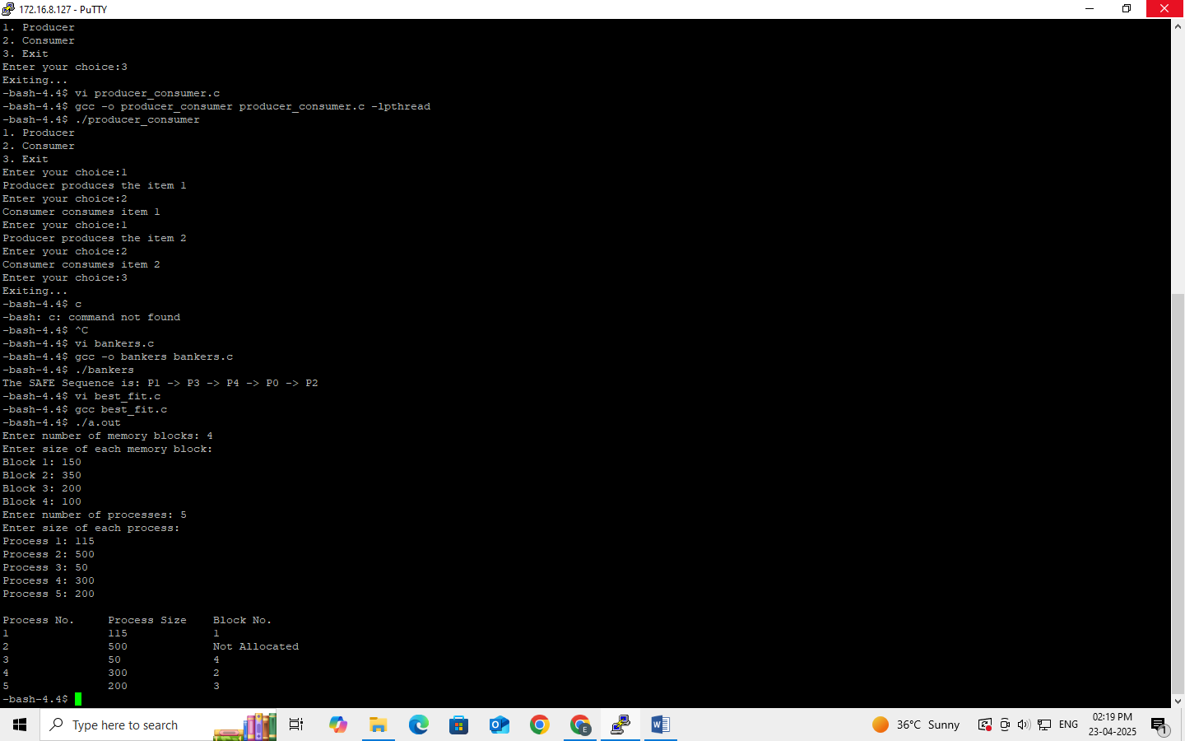

10 b) FIRST FIT
Program :
#include <stdio.h>
#define MAX 25
int main() {
int frag[MAX], b[MAX], f[MAX], bf[MAX], ff[MAX];
int i, j, nb, nf;
printf("Enter the number of blocks: ");
scanf("%d", &nb);
printf("Enter the number of files: ");
scanf("%d", &nf);

printf("Enter the size of each block:\n");
for (i = 0; i < nb; i++) {
printf("Block %d: ", i + 1);
scanf("%d", &b[i]);
bf[i] = 0; // mark all blocks as unallocated
}

printf("Enter the size of each file:\n");
for (i = 0; i < nf; i++) {
printf("File %d: ", i + 1);
scanf("%d", &f[i]);
}
for (i = 0; i < nf; i++) {
for (j = 0; j < nb; j++) {
if (bf[j] == 0 && b[j] >= f[i]) {
ff[i] = j;
frag[i] = b[j] - f[i];
bf[j] = 1; // mark block as allocated
break;
}
}
if (j == nb) {
ff[i] = -1; // file not allocated
frag[i] = -1;
}
}
printf("\nFile No\tFile Size\tBlock No\tBlock Size\tFragment\n");
for (i = 0; i < nf; i++) {
printf("%d\t%d\t\t", i + 1, f[i]);
if (ff[i] != -1)
printf("%d\t\t%d\t\t%d\n", ff[i] + 1, b[ff[i]], frag[i]);
else
printf("Not Allocated\n");
}
return 0;
}

OUTPUT :
